IRIS FLOWER CLASSIFICATION
Machine Learning Project Report

Multi-Class Classification of Iris Species from Flower Measurements
Dataset: scikit-learn Iris Dataset
150 flower samples · 4 measured features · 3 species
June 2026

1. Introduction
This project builds a classification model to identify the species of an iris flower — setosa, versicolor, or virginica — based on four physical measurements: sepal length, sepal width, petal length, and petal width. This is one of the most well-known introductory datasets in machine learning, prized for being small, clean, and perfectly suited to demonstrating the full classification workflow without data-quality distractions.
The dataset contains 150 flower samples, with exactly 50 samples of each of the three species, and no missing values in any column.

1.1 Objective
- Explore the relationships between flower measurements and species visually.
- Train a Random Forest classifier to predict species from measurements.
- Benchmark the model against a naive baseline to confirm genuine predictive value.
- Evaluate the model using cross-validation, a confusion matrix, and a classification report.
- Identify which measurements most influence the model's predictions.

2. Dataset Overview
The dataset is perfectly balanced across all three species (50 setosa, 50 versicolor, 50 virginica), with zero missing values across all four feature columns. This balance means plain accuracy is a fair and sufficient evaluation metric here, unlike imbalanced datasets where accuracy alone can be misleading.
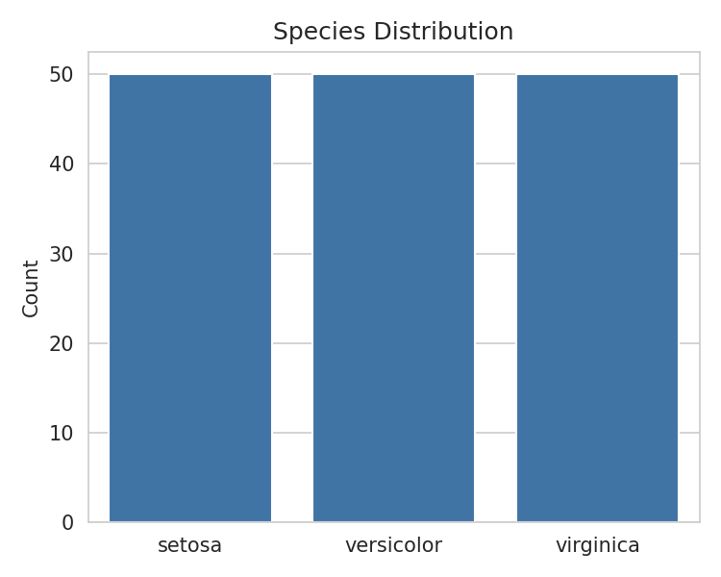
Figure 1. Species distribution — perfectly balanced at 50 samples each

2.1 Visual Relationships Between Features
A pairwise plot of all four features, colored by species, reveals how cleanly the species separate from one another:
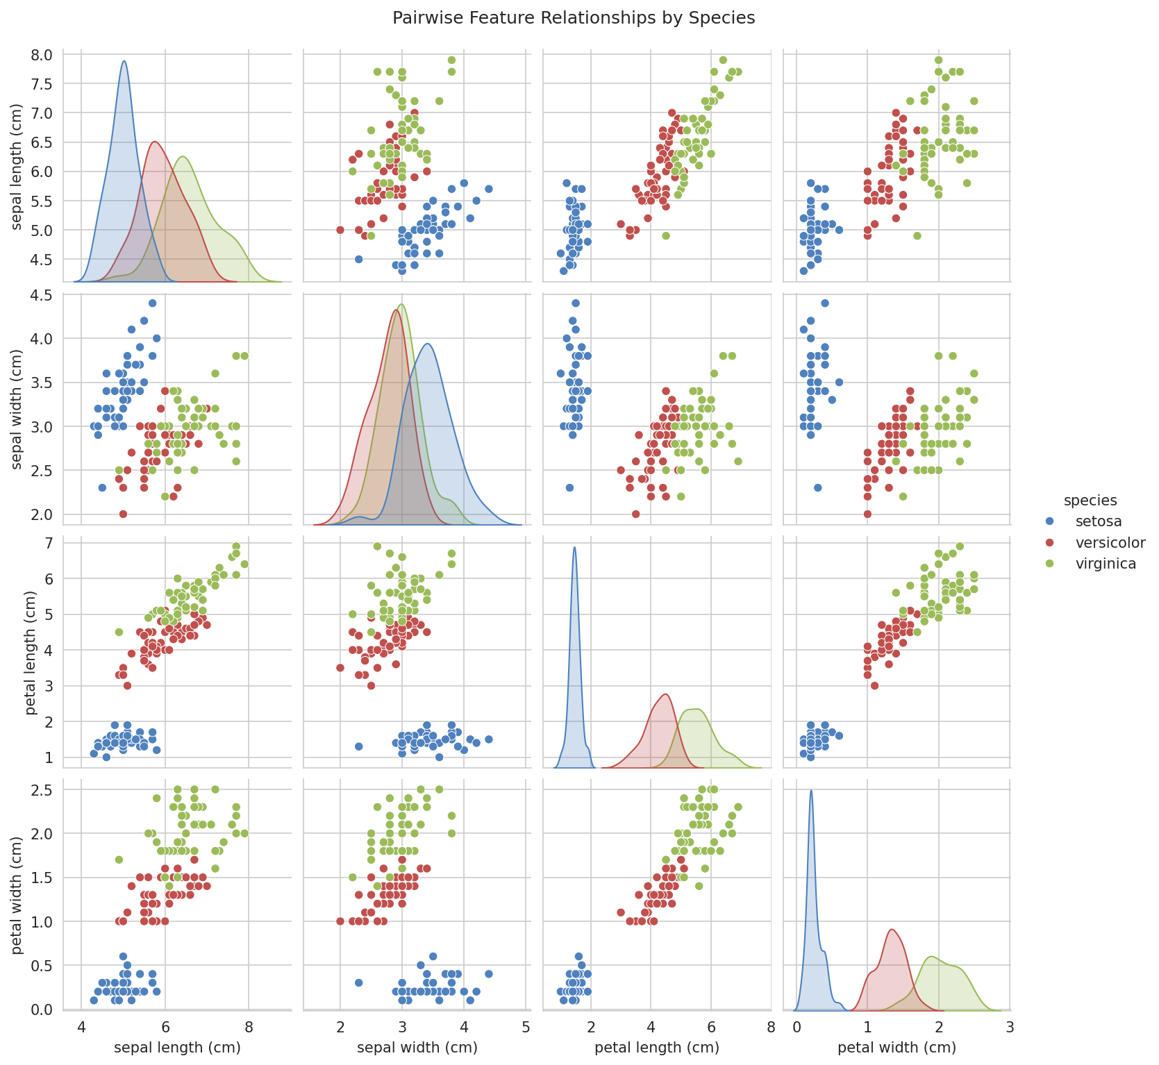
Figure 2. Pairwise relationships between all four features, colored by species
Setosa (blue) is clearly separated from the other two species across almost every feature pair, particularly petal length and petal width. Versicolor (red) and virginica (green) overlap more with each other, especially on sepal measurements, but remain largely distinguishable on petal length and petal width.

3. Modeling and Results

3.1 Data Split
The dataset was split into training and test sets using stratified sampling, ensuring each species remained proportionally represented in both sets. The training set contains 120 samples and the test set contains 30 samples (10 of each species).

3.2 Baseline Comparison
Given the dataset's small size, a single test-set accuracy figure can be noisy. A naive baseline — always predicting the most frequent class — provides a meaningful reference point any real model should clearly beat.
Model | Accuracy
Baseline (most frequent class) | 33.3%
Random Forest (test set) | 90.0%

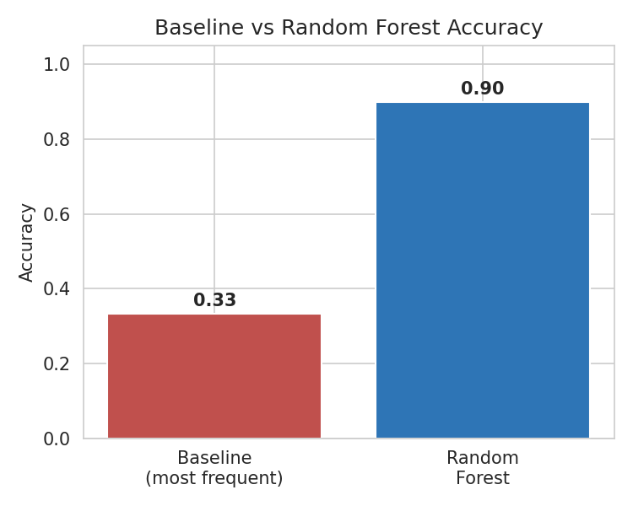
Figure 3. Baseline vs. Random Forest accuracy
The Random Forest model outperforms the baseline by 56.7 percentage points, confirming the flower measurements carry strong, genuine signal for distinguishing species — well beyond what guessing the majority class could achieve.

3.3 Cross-Validated Performance
5-fold cross-validation on the training set produced an accuracy of 95.0% ± 1.7%, which is consistent with — and more reliable than — the single test-set accuracy of 90.0%, given how small the test set (30 samples) is on its own.

3.4 Confusion Matrix
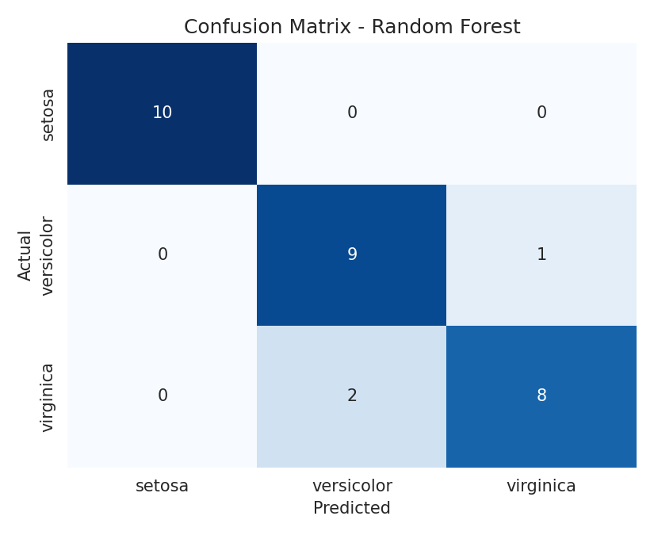
Figure 4. Confusion matrix for the Random Forest model on the test set
All 10 setosa samples were classified correctly, consistent with how visually distinct this species was in the pairplot. The model's only errors occurred between versicolor and virginica — one versicolor sample was misclassified as virginica, and two virginica samples were misclassified as versicolor, reflecting the overlap visible between these two species in Figure 2.

3.5 Classification Report
Species | Precision | Recall | F1-Score | Support
setosa | 1.00 | 1.00 | 1.00 | 10
versicolor | 0.82 | 0.90 | 0.86 | 10
virginica | 0.89 | 0.80 | 0.84 | 10
Weighted Avg | 0.90 | 0.90 | 0.90 | 30

3.6 Feature Importance
The Random Forest model's feature importance scores confirm the pattern visible in the pairplot:
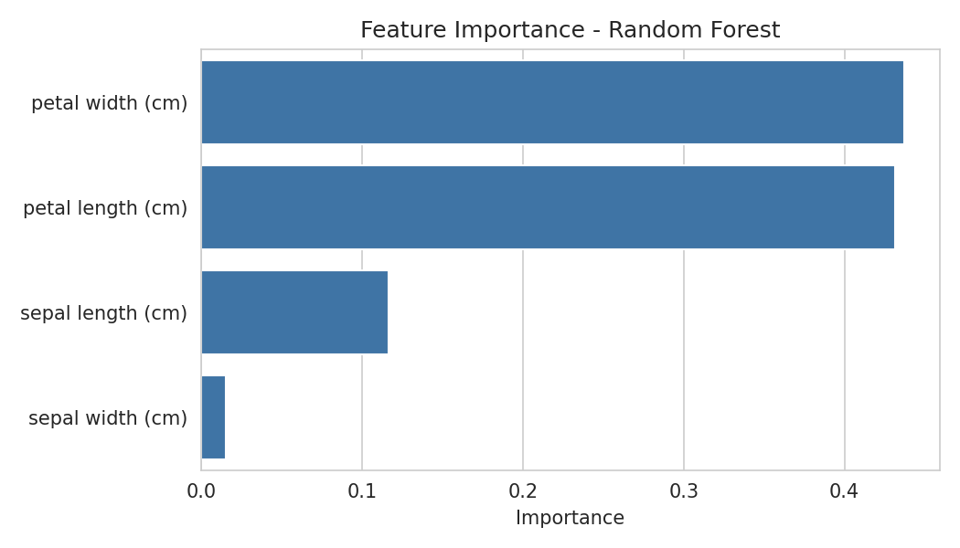
Figure 5. Feature importance from the Random Forest model
Petal width and petal length together account for roughly 87% of the model's decision-making, while sepal length and sepal width contribute comparatively little. This matches the visual separation observed in Figure 2, where petal measurements distinguished species far more cleanly than sepal measurements.

4. Prediction on a New Sample
To demonstrate the trained model in action, a new, previously unseen flower measurement was passed in: sepal length 5.1 cm, sepal width 3.5 cm, petal length 1.4 cm, petal width 0.2 cm.
The model predicted this sample to be: setosa. This is consistent with expectations, since the small petal measurements (1.4 cm length, 0.2 cm width) closely match the setosa cluster visible in Figure 2.

5. Conclusion
- The Random Forest model achieved 90% test accuracy and a more reliable cross-validated accuracy of 95%, well above the 33% baseline of guessing the majority class.
- Petal length and petal width were by far the most informative features, while sepal measurements contributed comparatively little — consistent with both the pairplot visualization and the model's internal feature importance scores.
- Setosa was classified with perfect accuracy, owing to its strong visual and statistical separation from the other two species; nearly all model errors occurred between the more visually similar versicolor and virginica classes.
- Using a stratified split and cross-validation produced a more trustworthy performance estimate than relying on a single 30-sample test set.

5.1 Possible Next Steps
- Try simpler models (e.g. Logistic Regression, K-Nearest Neighbors) — given how cleanly separable the classes are, a simpler model may match Random Forest performance with less complexity.
- Visualize decision boundaries in 2D using only petal length and petal width, since these two features alone carry most of the predictive signal.
- Investigate the few versicolor/virginica misclassifications individually to see if they sit near the natural boundary between the two species.

